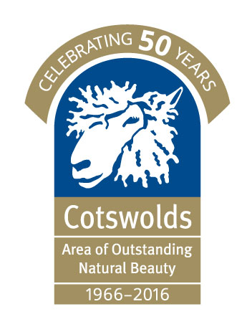


PRESS RELEASE – FOR IMMEDIATE RELEASE
20/06/2016

Parts of the Cotswolds AONB ranked as one of the darkest areas in southern England

The most detailed ever satellite maps of England’s light pollution and dark skies, released by the Campaign to Protect Rural England (CPRE), have shown that parts of the Cotswolds Area of Outstanding Natural Beauty (AONB) are ranked 13th in terms of the darkest skies in England.

The maps were produced using satellite images captured at 1.30 am throughout September 2015. This research comes at a time of increasing awareness of the harmful effects light pollution can have on the health of people and wildlife. That these skies were monitored at 1.30am illustrates just how long into the night England’s lighting spills outside of the Cotswolds AONB.

The Cotswolds Conservation Board has been considering whether parts of the Cotswolds AONB could be awarded Dark Sky status by the International Dark-Sky Association. The Rollright Stones near Chipping Norton already has Dark Sky Discovery Status.

Martin Lane, Director of the Cotswolds Conservation Board said: “Dark skies of the Cotswolds AONB have been fully recognised and included in the Tranquillity and Dark Skies Position Statement and revised Landscape Strategy and Guidelines for the Cotswolds, which include guidelines to conserve areas of dark skies and landscape and adopt measures to minimise existing light pollution.

The Board is exploring a bid to the International Dark Sky Association for parts of the Cotswolds to be recognised as a Dark Sky Reserve.

Keeping the lights out in the AONB is important to us. We were pleased to host a stargazing event at the Cotswolds Discovery Centre in Northleach in April in partnership with the Chipping Norton Amateur Astronomy Group. This event enabled the public to look through a wide range of powerful telescopes to observe the moon, planets and stars from the heart of the Cotswolds AONB. Looking up at night and seeing a star lit sky without disturbance from the lighting of neighbouring towns or cities really is a sight to enjoy.”

Richard Lloyd, Gloucestershire CPRE Vice Chairman said: “We would warmly support work towards achieving dark sky status for the Cotswolds AONB. Being able to enjoy and appreciate the magic of the night sky is one of the special qualities of the Cotswolds”.

CPRE is calling on local authorities to use these maps to identify areas with severe light pollution and target action to reduce it, as well as identifying existing dark skies that need protecting.

The new maps were produced by Land Use Consultants from data gathered by the National Oceanographic and Atmospheric Administration (NOAA) in America. The NOAA satellite captured visible and infrared imagery to determine the levels of light spilling up into British skies. CPRE is sending lesson plans to primary schools in order to promote the enjoyment of dark skies.

The interactive maps can be viewed by visiting http://nightblight.cpre.org.uk

ENDS

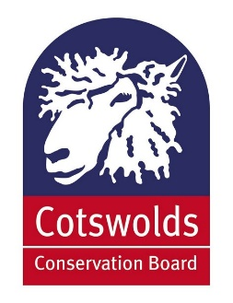
Media contact:
Chris Brant
Communications Officer
Tel: 01451 862003
Email: chris.brant@cotswoldsaonb.org.uk

Cotswolds Conservation Board, Fosse Way, Northleach, Gloucestershire GL54 3JH
Tel: 01451 862000 Website: www.cotswoldsaonb.org.uk

Notes to editors:
- CPRE’s interactive maps can be accessed at http://nightblight.cpre.org.uk
- Light pollution is a generic term referring to excess artificial light that shines where it is neither wanted nor needed. In broad terms, there are three types of light pollution:

- skyglow – the pink or orange glow we see for miles around towns and cities, spreading deep into the countryside, caused by a scattering of artificial light by airborne dust and water droplets

- glare – the uncomfortable brightness of a light source

- light intrusion – light spilling beyond the boundary of the property on which a light is located, sometimes shining through windows and curtains

- The Cotswolds was designated an Area of Outstanding Natural Beauty (AONB) in 1966 in recognition of its rich, diverse and high quality landscape. www.cotswoldsaonb.org.uk
- Download the Cotswolds AONB’s Position Statement; http://www.cotswoldsaonb.org.uk/userfiles/file/consultations/tranquillity-and-dark-skies-nov-09-revised-oct-2010.pdf
- The Cotswolds AONB is looked after by the Cotswolds Conservation Board – an independent organisation established in 2004 which has 37 members - 15 nominated by local authorities, 8 by parish councils and 14 appointed by the Secretary of State.
- The Cotswolds is the second largest protected landscape in England after the Lake District National Park and represents 10% of the total AONB area in the UK. It covers 2,038 square kilometres (790 square miles), stretching from Warwickshire and Worcestershire in the north, through Gloucestershire and Oxfordshire, down to Bath and Wiltshire in the south.
- Areas of Outstanding Natural Beauty (AONB), along with National Parks, are considered to be the most special landscapes in the country and belong to an international family of protected areas. There are 38 AONBs in England and Wales, and a further eight in Northern Ireland. For further details, visit: www.landscapesforlife.org.uk. For details of the 15 National Parks in England and Wales visit: www.nationalparks.gov.uk
- Over 350 Cotswold Voluntary Wardens dedicate thousands of hours of practical conservation work every year across the AONB, as well as lead an annual programme of guided walks and undertake a range of promotional and educational work.

